**AWS Snow Family**

**AWS Snow Family Members**

The [**AWS Snow Family**](https://aws.amazon.com/snow) is a collection of physical devices that help to physically transport up to exabytes of data into and out of AWS.

AWS Snow Family is composed of **AWS Snowcone**, **AWS Snowball**, and **AWS Snowmobile**.

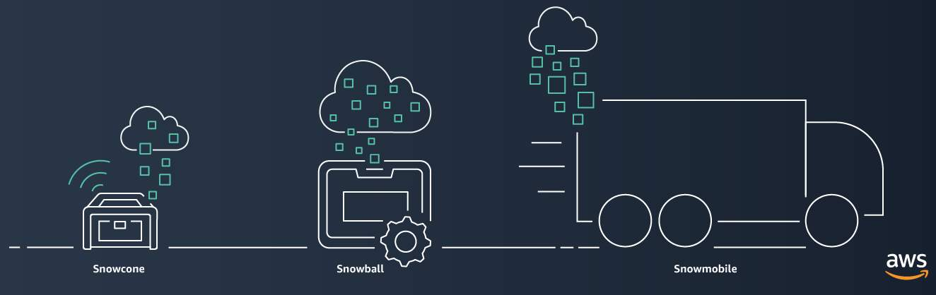

These devices offer different capacity points, and most include built-in computing capabilities. AWS owns and manages the Snow Family devices and integrates with AWS security, monitoring, storage management, and computing capabilities.

**AWS Snowcone**

[**AWS Snowcone**](https://aws.amazon.com/snowcone) is a small, rugged, and secure edge computing and data transfer device.

It features 2 CPUs, 4 GB of memory, and 8 TB of usable storage.

**AWS Snowball**

[**AWS Snowball**](https://aws.amazon.com/snowball/) offers two types of devices:

* **Snowball Edge Storage Optimized**devices are well suited for large-scale data migrations and recurring transfer workflows, in addition to local computing with higher capacity needs. Snowball Edge Storage Optimized provides 80 TB of HDD capacity for block volumes and Amazon S3-compatible object storage, and 1 TB of SATA SSD for block volumes.
* **Snowball Edge Compute Optimized**provides powerful computing resources for use cases such as machine learning, full motion video analysis, analytics, and local computing stacks.

**AWS Snowmobile**

[**AWS Snowmobile**](https://aws.amazon.com/snowmobile) is an exabyte-scale data transfer service used to move large amounts of data to AWS.

You can transfer up to 100 petabytes of data per Snowmobile, a 45-foot long ruggedized shipping container, pulled by a semi trailer truck.